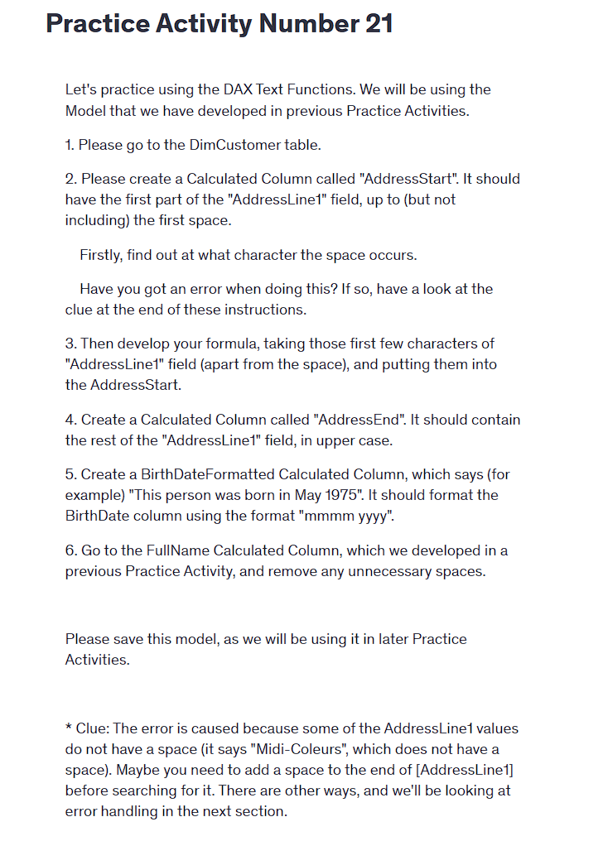

Practice Activity Number 21

Let's practice using the DAX Text Functions. We will be using the Model that we have developed in previous Practice Activities.

1. Please go to the DimCustomer table.

2. Please create a Calculated Column called "AddressStart". It should have the first part of the "AddressLine1" field, up to (but not including) the first space.

Firstly, find out at what character the space occurs.

Have you got an error when doing this? If so, have a look at the clue at the end of these instructions.

3. Then develop your formula, taking those first few characters of "AddressLine1" field (apart from the space), and putting them into the AddressStart.

4. Create a Calculated Column called "AddressEnd". It should contain the rest of the "AddressLine1" field, in upper case.

5. Create a BirthDateFormatted Calculated Column, which says (for example) "This person was born in May 1975". It should format the BirthDate column using the format "mmmm yyyy".

6. Go to the FullName Calculated Column, which we developed in a previous Practice Activity, and remove any unnecessary spaces.

Please save this model, as we will be using it in later Practice Activities.

\* Clue: The error is caused because some of the AddressLine1 values do not have a space (it says "Midi-Coleurs", which does not have a space). Maybe you need to add a space to the end of [AddressLine1] before searching for it. There are other ways, and we'll be looking at error handling in the next section.